**ACKNOWLEDGMENT**

With immense pleasure we would like to present this report on my topic **Driver Drowsiness Detection.** We are thankful to all that have helped us a lot for successful completion of our project and providing us courage for completing the work.

we thankful to our Head of the Department **Dr. Sandip Modha**, our internal faculty guide **Prof. Nimesh Patel**, for providing guidance throughout our work giving us their valuable time.

Finally, we would like to thank my parents and friends. who have directly or indirectly helped us in making the project work successfully.

YAGNANG ACHARYA [21BECE30003]

PARTH BAROT [21BECE30014]**ABSTRACT**

This document is a report on the research conducted and the project made in the field of computer engineering to develop a system for driver drowsiness detection to prevent accidents from happening because of driver fatigue and drowsiness. Drowsiness and fatigue are one of the main causes leading to road accidents. They can be prevented by taking effort to get enough sleep before driving, drinking coffee or energy drinks, or having a rest when the signs of drowsiness occur.

Human drivers have distinct driving techniques, knowledge, and sentiments due to unique driving traits. Driver drowsiness has been a serious issue endangering road safety; therefore, it is essential to design an effective drowsiness detection algorithm to bypass road accidents. Miscellaneous research efforts have approached the problem of detecting anomalous human driver behavior to examine the frontal face of the driver and automobile dynamics via computer vision techniques. Still, the conventional methods cannot capture complicated driver behavior features. However, with the origin of deep learning architectures, a substantial amount of research has also been executed to analyze and recognize driver’s drowsiness using neural network algorithms. This paper introduces a novel framework based on vision transformers and YoloV5 architectures for driver drowsiness recognition. A custom YoloV5 pre-trained architecture is proposed for face extraction with the aim of extracting Region of Interest (ROI).

**TABLE OF CONTENTS:**

|  |  |  |
| --- | --- | --- |
|  | Acknowledgment | i |
|  | Abstract | ii |
|  | Table of Contents | iii |
|  | List of Figures | iv |
| **1** | **Introduction**   * 1. Introduction   2. Human Psychology with Current Technology   3. Aim and Objectives   4. Problem Definition   5. Scope of Study   6. Relevancy of the Project   7. Plan of Work | 5 |
| **2** | **Literature Review and Technology**  2.1 Literature Review  2.2 Technology Used  2.3 Software Used | 11 |
| **3** | **System Requirements Study**  3.1 Hardware Requirements  3.2 Software Requirements | 20 |
| **4** | **System Design** | 23 |
| **5** | **Implementation**  5.1 Install and Import Dependencies  5.2 Loading Yolov5 Model  5.3 Making Detections with Images  5.4 Real Time Object Detections  5.5 Creating Dataset  5.6 Training the Model  5.7 Loading Custom Model | 27 |
| **6** | **Results and Conclusion** | 33 |
| **7** | **References** | 38 |

**TABLE OF FIGURES:**

|  |  |  |
| --- | --- | --- |
| **Figure no** | **Figure Name** | **Page No** |
| **1.1** | Trends in number of Accidents, Fatality and Persons Injured: 2016 to 2021 | 6 |
| **1.2** | Examples of Fatigue & Drowsiness Condition | 6 |
| **1.3** | Plan of Work | 10 |
| **2.1** | Examples of EEG Data Collecting | 12 |
| **2.2** | Examples of Eyelid Movement | 14 |
| **2.3** | Example of Person in Yawning Condition. | 15 |
| **4.1** | Use Case Diagram | 24 |
| **4.2** | Activity Diagram | 25 |
| **4.3** | Class Diagram | 26 |
| **6.1** | Detection of awake state | 34 |
| **6.2** | Detection of drowsy state | 34 |

**CHAPTER 1: INTRODUCTION**

* 1. **Introduction**
  2. **Human Psychology with Current Technology**
  3. **Aim and Objectives**
  4. **Problem Definition**
  5. **Scope of the Study**
  6. **Relevancy of the Project**

**1.1** **INTRODUCTION**:

Drowsiness is a state of near sleep, where the person has a strong desire for sleep. It has two distinct meanings, referring both to the usual state preceding falling asleep and the chronic condition referring to being in that state independent of a daily rhythm. Sleepiness can be dangerous when performing tasks that require constant concentration, such as driving a vehicle. When a person is sufficiently fatigue while driving, they will experience drowsiness and this leads to an increase the factor of road accidents.

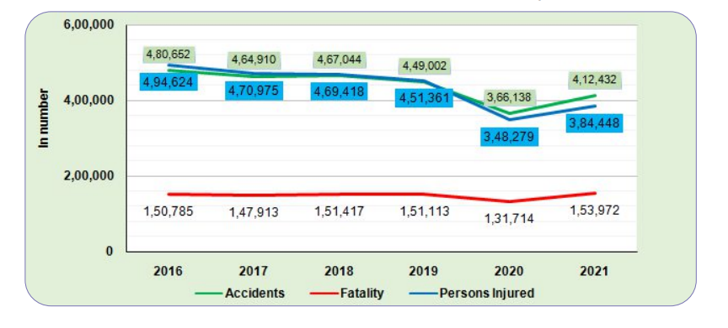

Figure 1.1: Trends in number of Accidents, Fatality and Persons Injured: 2016 to 2021

Figure 1 shows the statistics of road accidents in India from the year 2016 to 2021 provided by the Ministry of Road Transport and Highways. The numbers of vehicles involved in road accidents keep increasing each year.

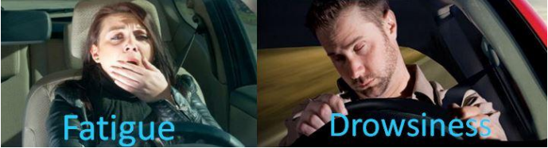

Figure 2.1: Examples of Fatigue & Drowsiness Condition

The development of technologies for detecting or preventing drowsiness while driving is a major challenge in the field of accident-avoidance systems. Because of the hazard that drowsiness presents on the road, methods need to be developed for counteracting its effects. The aim of this project is to develop a simulation of

drowsiness detection system. The focus will be placed on designing a system that will accurately monitor the

open or closed state of the driver’s eyes and mouth. By monitoring the eyes, it is believed that the symptoms of driver's drowsiness can be detected in sufficiently early stage, to avoid a car accident. Yawning detection is a method to assess the driver’s fatigue. When a person is fatigue, they keep yawning to ensure that there is enough oxygen for the brain consumption before going to drowsiness state. Detection of fatigue and drowsiness involves a sequence of images of a face, and the observation of eyes and mouth open or closed duration. Another method to detect eye closure is PERCLOS. This detection method is based on the time of eyes closed which refers to percentage of a specific time. The analysis of face images is a popular research area with applications such as face recognition, and human identification and tracking for security systems. This project is focused on the localization of the eyes and mouth, which involves looking at the entire image of the face, and determining the position of the eyes and mouth, by applying the existing methods in the image processing algorithm. Once the position of the eyes is located, the system is designed to determine whether the eyes and mouth are opened or closed, and detect fatigue and drowsiness

**1.2 Human Psychology with Current Technology**

Humans have always invented machines and devised techniques to ease and protect their lives, for mundane activities like traveling to work, or for more interesting purposes like aircraft travel. With the advancement in technology, modes of transportation kept on advancing and our dependence on it started increasing exponentially. It has greatly affected our lives as we know it. Now, we can travel to places at a pace that even our grandparents wouldn’t have thought possible. In modern times, almost everyone in this world uses some sort of transportation every day. Some people are rich enough to have their own vehicles while others use public transportation. However, there are some rules and codes of conduct for those who drive irrespective of their social status. One of them is staying alert and active while driving. Neglecting our duties towards safer travel has enabled hundreds of thousands of tragedies to get associated with this wonderful invention every year. It may seem like a trivial thing to most folks but following rules and regulations on the road is of utmost importance. While on road, an automobile wields the most power and in irresponsible hands, it can be destructive and sometimes, that carelessness can harm lives even of the people on

the road. One kind of carelessness is not admitting when we are too tired to drive. In order to monitor and prevent a destructive outcome from such negligence, many researchers have written research papers on driver drowsiness detection systems. But at times, some of the points and observations made by the system are not accurate enough. Hence, to provide data and another perspective on the problem at hand, in order to improve their implementations and to further optimize the solution, this project has been done.

**1.3 Aim and Objectives**

* Aim:

Driver Drowsiness Detection by Using Webcam is being introduced to minimize and reduce the number of accidents involving cars, lorries and trucks. It detects the drowsiness signs and alerts drivers when they are in drowsy state

* Objectives:

The project focuses on these objectives, which are:

* To suggest ways to detect fatigue and drowsiness while driving.
* To study on eyes and mouth from the video images of participants in the experiment of driving simulation conducted by MIROS that can be used as an indicator of fatigue and drowsiness.
* To investigate the physical changes of fatigue and drowsiness
* To develop a system that use eyes closure and yawning as a way to detect fatigue and drowsiness

**1.4 Problem Definition**

Driver Drowsiness Detection is the Process of Identifying when a driver is becoming fatigued or drowsy while operating a vehicle which is done through the use of Cameras and machine learning algorithms to detect signs of drowsiness such as yawning, drooping eyelids and changes IN facial expressions. The goal of this technology is to prevent accidents caused by drowsy driving.

**1.5 Scope of Study**

In this project, the author will focus on these following procedures:

* Basic concept of drowsiness detection system
* Familiarize with the signs of drowsiness
* Data collection and measurement
* Integration of the methods chosen.
* Coding development and testing.
* Complete testing and improvement

**1.6 Relevancy of Project**

This project is relevant to the implementation since fatigue and drowsiness drivers contribute to the percentage of road accidents. Many researches have been conducted to implement safe driving systems in order to reduce road accidents. Detecting the driver’s alertness and drowsiness is an efficient way to prevent road accidents. With this system, drivers who are drowsy will be alerted by an alarm to regulate consciousness, attention and concentration of the drivers. This will help to reduce the number of road accidents.

This project is an active topic that is still being enhanced and improved by research and can be applied in many areas such as detecting the attention-level of students in classrooms and lectures. This is also relevant to the three author’s fields of study since it requires the author to apply and combine the knowledge of electronics, programming and algorithms.

* 1. **Plan of Work**

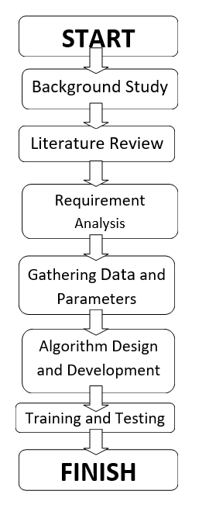

Figure 1.3 Plan of Work**CHAPTER 2: LITERATURE REVIEW AND TECHNOLOGY**

**2.1 Literature Review**

**2.2 Technology Used**

**2.3 Software Used**

**2.1** **Literature Review**

There is much previous research regarding driver drowsiness detection systems that can be used as a reference to develop a real-time system on detecting drowsiness for drivers. There are also several methods which use different approaches to detect the drowsiness signs. According to MORTH (Ministry of Road Transport and Highways) the number of road accidents across India amounted to around 336 thousand in 2020.

**2.1.1 Drowsiness and Fatigue**

Drowsiness is when a person is in the middle of an awake and sleepy state. This situation leads the driver to not giving full attention to their driving. Therefore, the vehicle can no longer be controlled due to the driver being in a semi-conscious state. Mental fatigue is a factor of drowsiness and it causes the person who experiences to not be able to perform because it decreases the efficiency of the brain to respond towards sudden events.

**2.1.2 Electroencephalography (EEG) for Drowsiness Detection**

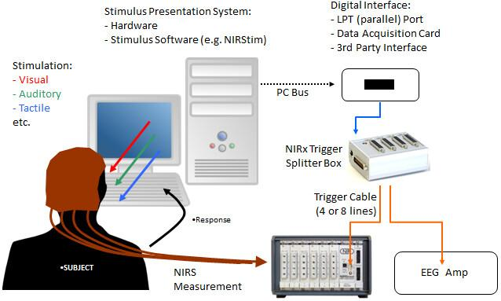

**Figure 2.1: Examples of EEG Data Collecting**

Electroencephalography (EEG) is a method that measures the brain's electrical activity. As shown in Figure 3, it can be used to measure the heartbeat, eye blink and even major physical movement such as head movement. It can be used on humans or animals as subjects to get brain activity.

It uses a special hardware that places sensors around the top of the head area to sense any electrical brain activity. It has been implemented by the previous researcher to detect drowsiness signs, the EEG method is best to be applied for drowsiness and fatigue detection. In the method, EEG has four types of frequency components that can be analyzed, i.e., alpha (α), beta (β), theta (θ) and delta (δ). When the power is increased in alpha (α) and delta (δ) frequency bands, it shows that the driver is facing fatigue and drowsiness. The disadvantages of this method are, it is very sensitive to noise around the sensors. For example, when the person is doing the EEG experiment, the surrounding area must be completely silent. The noise will interfere with the sensors that detect the brain activity. Another disadvantage of this method is that even if the result might be accurate, it is not suitable to use for real driving applications. Imagine when a person is driving and he is wearing something on his head full of wires and when the driver moves their head, the wire may strip off from their place. Even though it is not convenient to be used for real-time driving but for experiment purposes and data collection, it is one of the best methods so far.

**2.1.3 Drowsiness detection using face detection system**

Drowsiness can be detected by using face area detection. The methods to detect drowsiness within face area vary due to drowsiness signs are more visible and clearer to be detected at face area. From the face area, we can detect the eyes’ location. From eyes detection, the author stated that there are four types of eyelid movement that can be used for drowsiness detection. They are completely open, complete close, and in the middle where the eyes are from open to close and vice versa. Figure 4 is an example of the image taken for detecting eyelid movement.

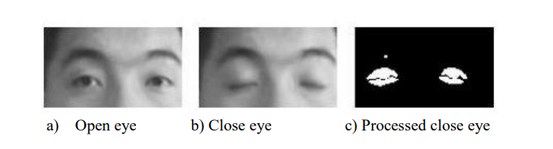

**Figure 2.2: Examples of Eyelid Movement**

The algorithm processes the images captured in a gray-scale method; where the color from the images is then transformed into black and white. Working with black and white images is easier because only two parameters have to be measured. The author then performs the edge detection to detect the edges of eyes so that the value of eyelid area can be calculated. The problem occurring with this method is that the size of the eye might vary from one person to another. Someone may have small eyes and look like they are sleepy but some are not. Other than that, if the person is wearing glasses, there is an obstacle to detect eye regions. The images that are captured must be in a certain range from the camera because when the distance is far from the camera, the images are blurred.

**2.1.4 PERCLOS (Percentage of Eye Closure)**

Drowsiness can be captured by detecting the eye blinks and percentage of eye closure (PERCLOS). For eye blink detection, propose a method which learns the pattern of duration of eyelid closed. According to, ‘this proposed method measures the time for a person to close their eyes and if they are closed longer than the normal eye blink time, it is possible that the person is falling asleep’. In, the author mentioned that ‘nearly 310.3ms are the average of normal person eye blink’.

The PERCLOS method proposes that drowsiness is measured by calculating the percentage of the eyelid ‘droops. Sets of eyes open and eye closed have been stored in the software library to be used as a parameter to differentiate whether the eyes is fully open or fully closed. For eyelids to droop, it happens much slower as the person is slowly falling asleep. Hence, the transition of the

the driver's drowsiness can be recorded. Thus, PERCLOS method puts a proportional value where when the eyes are 80% closed, which is nearly too fully closed, it assumes that the driver is drowsy.

This method is not convenient to be used in real-time driving as it needs to fix the threshold value of eye opening for the PERCLOS method to perform accurately. Both methods to detect drowsiness using eye blink patterns and PERCLOS have the same problem where the camera needs to be placed at a specific angle in order to get a good image of video with no disturbance of eyebrow and shadow that cover the eyes.

**2.2 Technology Used**

* **Python:** Python is a popular language for machine learning because it has a large and active community, a wealth of powerful libraries and frameworks, and a relatively simple and easy-to-learn syntax. Some of the most popular libraries and frameworks for machine learning in Python include TensorFlow, Keras, scikit-learn, and PyTorch. These libraries provide a wide range of tools and capabilities for tasks such as data preprocessing, model training and evaluation, and deployment. Additionally, Python has a wide range of other libraries and tools that are useful for machine learning, such as NumPy and pandas for data manipulation, and Matplotlib and Seaborn for data visualization.
* **Machine Learning:** Machine learning is a branch of [artificial intelligence (AI)](https://www.ibm.com/topics/artificial-intelligence) and computer science which focuses on the use of data and algorithms to imitate the way that humans learn, gradually improving its accuracy. Machine learning is a method of data analysis that automates analytical model building. It is a branch of artificial intelligence based on the idea that systems can learn from data, identify patterns and make decisions with minimal human intervention.
* **Transfer Learning:** Transfer learning is a technique in machine learning where a model trained on one task is reused as the starting point for a model on a second related task. The idea behind transfer learning is that many features learned by a model on one task can be reused on a second related task, allowing the second model to learn more quickly and perform better. Transfer learning is widely used in computer vision and natural language processing, where a model pre-trained on a large dataset can be fine-tuned on a smaller dataset. Transfer learning enables an efficient use of labeled data and time, allowing to solve problems with limited data, and achieve better performance in comparison to training a model from scratch.
* **Dlib Library**: Dlib is a versatile C++ library primarily used for machine learning and computer vision tasks. It offers a wide range of functionalities, including face detection, facial landmark detection, object detection, image processing, and more. Dlib is known for its efficiency, reliability, and ease of integration into projects.

Key Features:

* **Face Detection**: Dlib provides a pre-trained face detector capable of accurately detecting faces within images or video frames. This face detector is optimized for real-time performance and can identify multiple faces within a single image.
* **Facial Landmark Detection**: The library includes a facial landmark detector capable of identifying specific points on the face, such as the corners of the eyes, nose, mouth, etc. These landmarks are crucial for tasks like face alignment, facial expression analysis, and drowsiness detection.
* **Machine Learning Algorithms**: Dlib offers various machine learning algorithms and tools, including support vector machines (SVM), deep learning, clustering algorithms, and more. These algorithms can be used for classification, regression, clustering, and other tasks.
* **Image Processing**: Dlib provides a set of tools for image processing tasks such as resizing, rotation, cropping, filtering, and enhancing images. These functionalities are essential for preparing images for analysis or visualization.
* **Graphical User Interface (GUI) Components**: The library includes GUI components for creating interactive applications, visualizing data, and displaying images or video streams. These components make it easier to develop user-friendly interfaces for machine learning or computer vision projects.
* **Cross-Platform Compatibility**: Dlib is designed to be cross-platform and can run on various operating systems, including Windows, macOS, and Linux. This compatibility ensures that projects developed using Dlib can be deployed across different platforms without significant modifications.

**2.3 Software Used**

* **Visual Studio Code (VSCode):** is a versatile and lightweight source code editor developed by Microsoft. It offers a rich set of features including cross-platform support, extensive customization through extensions, intelligent code editing with features like syntax highlighting and code completion, built-in Git support for version control, debugging capabilities, task automation, an integrated terminal, and collaboration tools such as Live Share. With its user-friendly interface and robust functionality, VSCode has become a favored choice among developers for coding and software development tasks across different programming languages and platforms.
* **OpenCV**: OpenCV (Open-Source Computer Vision) is a library of programming functions mainly aimed at real-time computer vision. It is open-source, cross-platform, and has a large community of developers and users. OpenCV is written in C++ but also has interfaces for Python, Java, and MATLAB/OCTAVE. It is widely used in computer vision, image processing, and video analysis tasks, including object detection, image recognition, and 3D reconstruction.

OpenCV provides a wide range of tools for image and video processing, including:

* Image and video input/output
* Image filtering, feature detection and description, and object detection
* Camera calibration, stereo vision, and 3D reconstruction
* Machine learning algorithms for image and video analysis

OpenCV has a strong focus on real-time applications and it's widely used in robotics, self-driving cars, security systems, and many other domains that require real-time image and video processing. It's supported on a wide range of platforms and it's easy to integrate with other libraries. It's also commonly used in conjunction with other libraries such as TensorFlow, Keras, and PyTorch for image and video processing tasks, particularly in the field of computer vision.

* **Dlib (a C++ toolkit containing machine learning algorithms and tools)**: Dlib is utilized for face detection and facial landmark detection. It offers pre-trained models and algorithms for these tasks, making it convenient for implementing facial analysis functionalities in the program. Specifically, the program uses Dlib's face detector (dlib.get_frontal_face_detector) and facial landmark predictor (dlib.shape_predictor) to detect faces and locate facial landmarks, respectively.
* **Streamlit**: Streamlit is a Python library used for creating web applications for machine learning and data science projects. It provides an easy-to-use interface for building interactive web applications directly from Python scripts. In this program, Streamlit is used to create a user interface for setting parameters, enabling/disabling alert music, and starting/stopping the drowsiness detection process (st.title, st.sidebar, st.slider, st.checkbox, st.image, st.write).
* **Pygame**: Pygame is a set of Python modules designed for writing video games. In this program, Pygame's mixer module (pygame.mixer) is used for loading and playing the alert sound ("music.wav") when drowsiness is detected.
* **Imutils**: Imutils is a series of convenience functions to make basic image processing tasks easier with OpenCV. In this program, Imutils is used for resizing frames (imutils.resize).

**CHAPTER 3: SYSTEM REQUIREMENT STUDY**

**3.1 Hardware Requirements**

**3.2 Software Requirements**

**3.1 Hardware Requirements**

* Webcam
* Laptop with Basic Hardware
* Minimum 8 GB of RAM
* Free Space of 10 GB

**3.2 Software Requirements**

* Operating System
  + Windows or Linux
* Programming Language
  + Python 3**CHAPTER 4: SYSTEM DESIGN**

**4.1 Use Case Diagram**

**4.2 Activity Diagram**

**4.3 Class Diagram**

**4.1 Use Case Diagram**

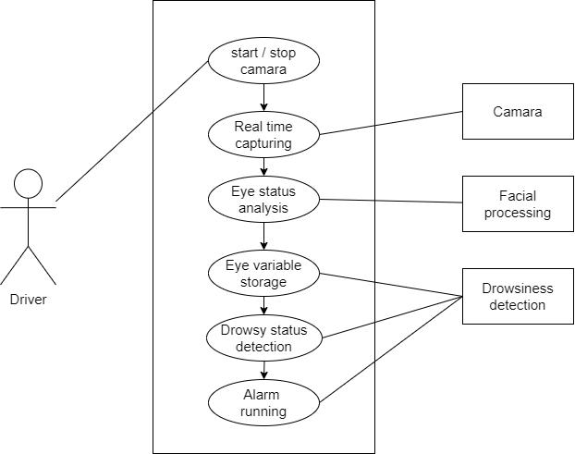

**4.2 Activity Diagram**

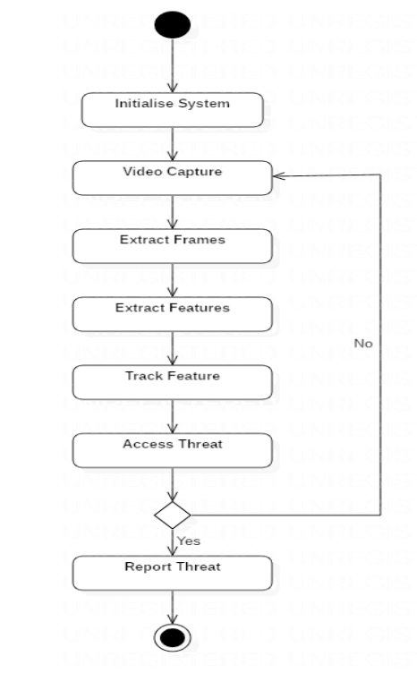

**4.3 Class Diagram**

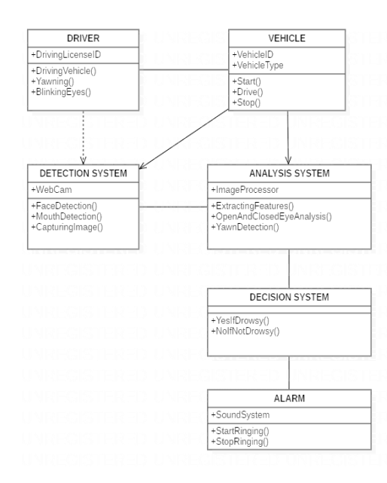

**CHAPTER 5: IMPLEMENTATION**

1. **Initialization and Setup**
2. **User Interface Creation**
3. **Alert Sound Initialization**
4. **Eye Aspect Ratio Computation**
5. **Drowsiness Detection Logic**
6. **Video Capture and Processing**
7. **Face and Facial Landmark Detection**
8. **Streamlit Interface Setup**
9. **Main Functionality Execution**

**# Import Dependencies**

import cv2

import dlib

import imutils

import streamlit as st

from imutils import face_utils

from pygame import mixer

from scipy.spatial import distance

**# Step 1: Initialize necessary libraries and modules**

def initialize():

**# Step 1.1: Initialize Pygame mixer for audio playback**

mixer.init()

**# Step 1.2: Load the alert sound file**

mixer.music.load("music.wav")

return mixer

def eye_aspect_ratio(eye):

**# Step 1.3: Define function to compute eye aspect ratio (EAR)**

A = distance.euclidean(eye[1], eye[5])

B = distance.euclidean(eye[2], eye[4])

C = distance.euclidean(eye[0], eye[3])

ear = (A + B) / (2.0 * C)

return ear

**# Step 2: Define function for drowsiness detection**

def Drowsiness_detection(cap, thresh, frame_check, mixer):

detect = dlib.get_frontal_face_detector()

predict = dlib.shape_predictor("models/shape_predictor_68_face_landmarks.dat")

(lStart, lEnd) = face_utils.FACIAL_LANDMARKS_68_IDXS["left_eye"]

(rStart, rEnd) = face_utils.FACIAL_LANDMARKS_68_IDXS["right_eye"]

flag = 0

FRAME_WINDOW = st.image([])

while True:

ret, frame = cap.read()

frame = imutils.resize(frame, width=450)

gray = cv2.cvtColor(frame, cv2.COLOR_BGR2RGB)

subjects = detect(gray, 0)

for subject in subjects:

shape = predict(gray, subject)

shape = face_utils.shape_to_np(shape)

leftEye = shape[lStart:lEnd]

rightEye = shape[rStart:rEnd]

leftEAR = eye_aspect_ratio(leftEye)

rightEAR = eye_aspect_ratio(rightEye)

ear = (leftEAR + rightEAR) / 2.0

leftEyeHull = cv2.convexHull(leftEye)

rightEyeHull = cv2.convexHull(rightEye)

cv2.drawContours(gray, [leftEyeHull], -1, (0, 255, 0), 1)

cv2.drawContours(gray, [rightEyeHull], -1, (0, 255, 0), 1)

if ear < thresh:

flag += 1

if flag >= frame_check:

cv2.putText(

gray,

"****************ALERT!****************",

(10, 30),

cv2.FONT_HERSHEY_SIMPLEX,

0.7,

(0, 0, 255),

2,

)

cv2.putText(

gray,

"****************ALERT!****************",

(10, 325),

cv2.FONT_HERSHEY_SIMPLEX,

0.7,

(0, 0, 255),

2,

)

if mixer:

mixer.music.play()

else:

flag = 0

FRAME_WINDOW.image(gray)

**# Step 3: Define the main function for the Streamlit app**

def main():

st.title("Drowsiness Detection")

st.sidebar.title("Parameters")

thresh = st.sidebar.slider(

"Threshold", min_value=0.1, max_value=0.5, value=0.25, step=0.01

)

frame_check = st.sidebar.slider(

"Frame Check", min_value=5, max_value=50, value=20, step=5

)

st.sidebar.title("Music")

play_music = st.sidebar.checkbox("Play Alert Music")

run = st.checkbox("Start Detection")

if run:

cap = cv2.VideoCapture(0)

mixer = initialize() if play_music else None

Drowsiness_detection(cap, thresh, frame_check, mixer)

else:

st.write("Stopped")

if __name__ == "__main__":

main()

**CHAPTER 6: RESULTS AND CONCLUSIONS**

**6.1 Detection of awake state**

**6.2 Detection of drowsy state**

**6.4 Applications of the System**

**6.5 Advantages of the System**

**6.6 Drawbacks of the System**

**6.7 Future Scope**

**6.8 Conclusion**

**6.1 Detection of awake state**

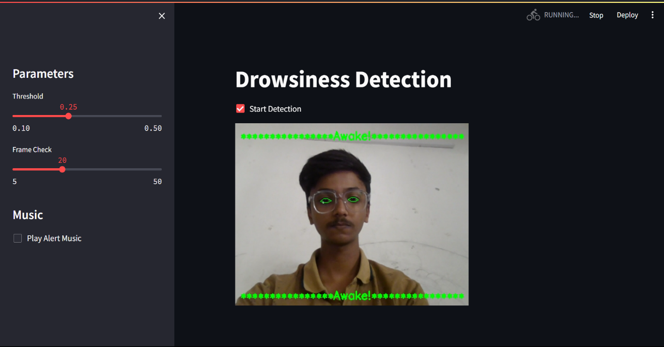

**6.2 Detection of awake state**

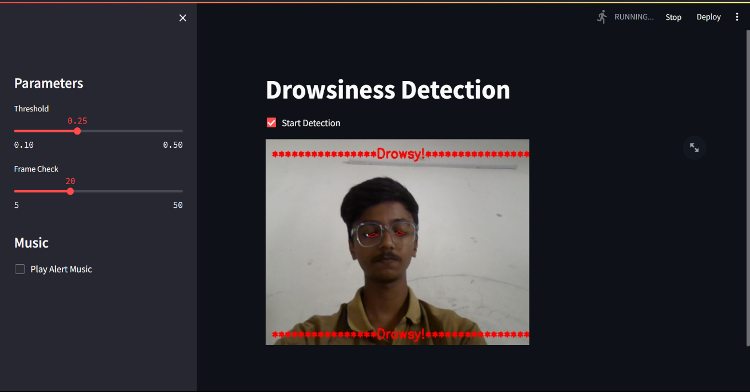

**6.3 Applications of the System**

1. **Automotive industry**: Driver drowsiness detection systems can be integrated into cars and trucks to alert drivers when they show signs of drowsiness and to prevent accidents caused by fatigue.
2. **Long-distance trucking**: Drowsiness detection systems can be particularly useful for long-distance truck drivers who spend many hours on the road and are at a higher risk of fatigue-related accidents.
3. **Public transportation**: Drowsiness detection systems can be used in buses and trains to monitor the alertness of the driver and to ensure the safety of passengers.
4. **Fleet management**: Drowsiness detection systems can be used to monitor the alertness of drivers in a fleet of vehicles and to identify patterns of drowsiness that may need to be addressed.
5. **Self-driving cars**: Drowsiness detection systems can be used in autonomous vehicles to ensure that the car's AI is alert and responsive at all times.
6. **Military and law enforcement**: Drowsiness detection systems can be used in military vehicles and law enforcement vehicles to ensure the safety of the driver and passengers.
7. **Mining and construction**: Drowsiness detection systems can be used in heavy machinery such as dump trucks, excavators, and bulldozers to prevent accidents caused by fatigue.

**6.4 Advantages of the System**

1. **Increased safety:** Drowsiness detection systems can help to prevent accidents caused by fatigue by alerting drivers when they show signs of drowsiness and encouraging them to take a break.
2. **Cost-effective:** Drowsiness detection systems can help to reduce the costs associated with fatigue-related accidents, such as medical expenses, vehicle repairs, and legal fees.
3. **Improved productivity:** Drowsiness detection systems can help to increase the productivity of long-distance truck drivers and other professionals who spend many hours on the road by ensuring that they are alert and well-rested.
4. **Early detection:** Drowsiness detection systems can detect signs of drowsiness early on, before the driver becomes too tired to function properly, which can help to prevent accidents before they happen.
5. **Customizable:** Drowsiness detection systems can be customized to suit the specific needs of different types of vehicles and drivers, such as long-distance truck drivers or autonomous vehicle operators.
6. **Better driver performance:** Drowsiness detection systems can help drivers identify when they are getting tired and take appropriate measures to improve their performance and safety on the road.
7. **Fit for different environments:** Drowsiness detection systems can be applied to different environments like cars, buses, trains, heavy vehicles, and off-road vehicles.

**6.5 Drawbacks of the System**

1. **False alarms:** Drowsiness detection systems can sometimes mistake other factors, such as a person blinking or looking away from the road, for actual drowsiness. This can lead to false alarms and can be frustrating for the driver.
2. **Limited accuracy:** Limited accuracy and effectiveness, particularly in low-light conditions.
3. **Privacy concerns:** Some people may be uncomfortable with the idea of cameras and sensors monitoring their actions and movements while driving.
4. **Limited field of view:** Some driver drowsiness detection systems only monitor the driver's face, and may not detect other signs of drowsiness such as nodding off or drifting out of the lane.
5. **Limited applicability:** Drowsiness detection systems may not be effective for all types of vehicles and environments, such as heavy vehicles or off-road vehicles.
6. **Limited to driver:** Drowsiness detection systems only monitor the driver, but there may be other factors that could cause the accident such as a passenger distracting the driver.

**6.6 Future Scope**

The future scope for driver drowsiness detection is promising as it can greatly improve road safety. Here are a few potential future developments in this field:

1. **Integration with vehicle systems:** Drowsiness detection systems could be integrated with other in-vehicle systems, such as lane departure warning and adaptive cruise control, to create a more comprehensive safety system.
2. **Advanced sensors:** New sensors and technologies, such as infrared cameras, 3D cameras, and EEG sensors, could be used to more accurately detect signs of drowsiness.
3. **Personalized drowsiness detection:** The system could learn the driver's habits and routines to give personalized drowsiness alerts based on the driver's sleep schedule, fatigue level, etc.
4. **Integration with smart devices:** Smart devices such as smartphones, smartwatches, and fitness trackers could be used to monitor drivers' sleep patterns and provide personalized drowsiness alerts.

Overall, with the integration of advanced technology and the use of machine learning and AI, drowsiness detection systems have the potential to significantly improve road safety.

**6.7 Conclusion**

Driver drowsiness detection systems use a variety of methods to detect when a driver is becoming fatigued, including monitoring eye movement, head position, and facial expression. These systems can be effective in reducing the risk of accidents caused by drowsy driving. However, these systems are not foolproof, and it is still important for drivers to be aware of their own level of fatigue and to pull over and rest when necessary. Additionally, some systems may raise privacy concerns. Overall, driver drowsiness detection systems are a promising technology for improving road safety, but more research and development is needed to improve their reliability and address privacy concerns.

**CHAPTER-7 REFERENCES**

* <https://docs.opencv.org/4.x/>
* <https://en.wikipedia.org/wiki/Transfer_learning>
* <https://docs.python.org/3/>
* <https://github.com/nicknochnack/YOLO-Drowsiness-Detection>
* <https://github.com/heartexlabs/labelImg>